LLM PROMPT MONITORING AND DATA LEAKAGE PREVENTION SYSTEM
SURYA PRAKASH S (2403717672621053) | SWARNAMITHRA M (2403717672622054)
SOFTWARE ENGINEERING (20MSS43)

1. PROBLEM STATEMENT
Organizations are increasingly adopting Large Language Models (LLMs) such as ChatGPT to improve productivity and automate tasks. However, users often provide sensitive information such as passwords, personal data, and financial details while interacting with these systems, which can lead to potential data leakage.
Existing approaches either completely restrict access to AI tools, reducing productivity, or allow unrestricted usage, increasing security risks.
Therefore, there is a need for a system that can monitor user inputs, detect sensitive information, and enforce appropriate security policies.
This project proposes a Java-based proxy system that acts as an intermediary between users and LLM services, ensuring secure and controlled usage.

2. FUNCTIONAL REQUIREMENTS

2.1 Prompt Interception
The system shall capture user input before it is sent to the LLM.

2.2 Sensitive Data Detection
The system shall identify sensitive information such as:
- Email addresses
- Passwords or secret keys
- Credit card numbers
- (Future Scope) Phone numbers

2.3 Policy Enforcement
The system shall apply predefined policies based on detected data:
- BLOCK – for highly sensitive data (e.g., credit card details)
- MASK – for partially sensitive data (e.g., email addresses)
- ALLOW – for safe inputs

2.4 Response Generation
The system shall return a modified or blocked response based on policy decisions.

2.5 API Interface
The system shall provide APIs for interaction:
- /llm endpoint for main processing
- /detect endpoint for detection module

3. NON-FUNCTIONAL REQUIREMENTS

3.1 Performance
The system should respond within 2 seconds.

3.2 Security
Sensitive data must not be exposed to external systems. API access should be controlled.

3.3 Scalability
The system should support multiple users simultaneously.

3.4 Maintainability
The system should follow a modular design for easy updates and enhancements.

3.5 Reliability
The system should handle invalid or unexpected inputs gracefully.

4. USECASE DIAGRAM

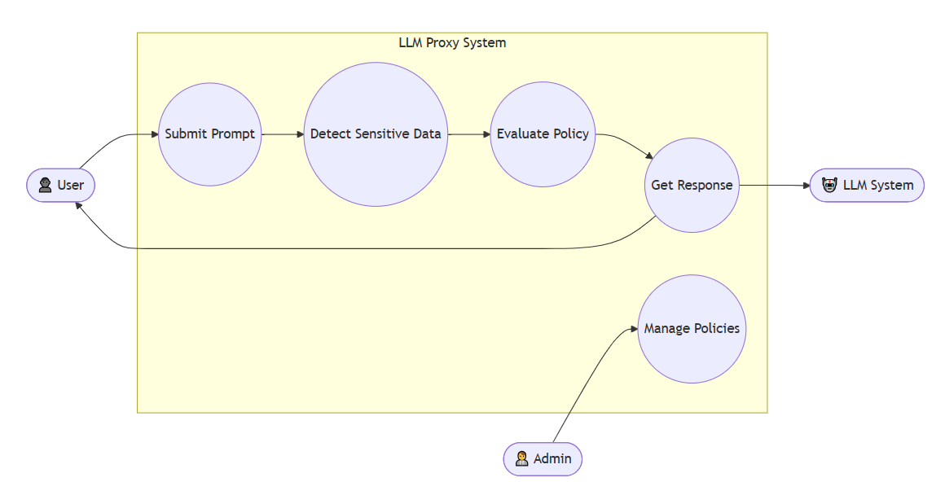

5. CLASS DIAGRAM

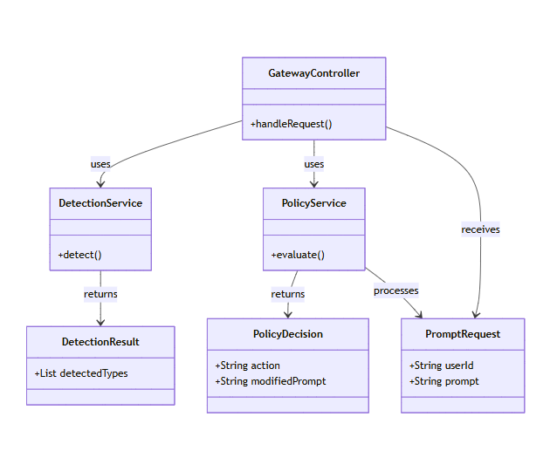

6. SEQUENCE DIAGRAM

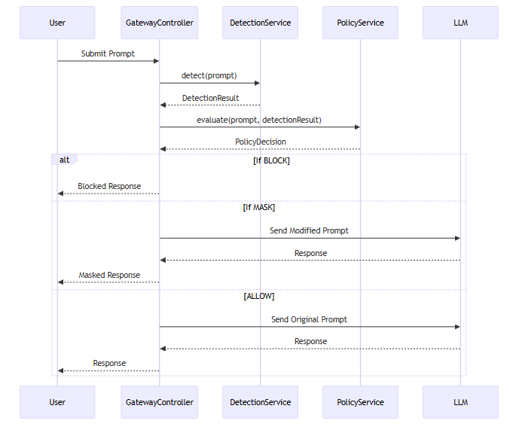

7.ACTIVITY DIAGRAM

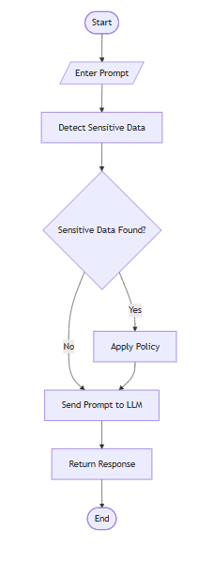
8. ARCHITECTURE DIAGRAM

